**Instructions to run the program CWB**

**1st method**

Please open Pycharm and run Task 1 and task 2

**2nd method to open it if the path file is not working**

Open Pycharm and create new project and/or a new package.

Copy DADSA 2021 CWK B DATA COLLECTION csv and copy task 1 then run it

Copy DADSA 2021 CWK B DATA COLLECTION csv and copy task 2 then run it

Or copy all the files and paste it (might have to do it one file at a time)

Here is an image instruction to show the steps

1.

2.

3.

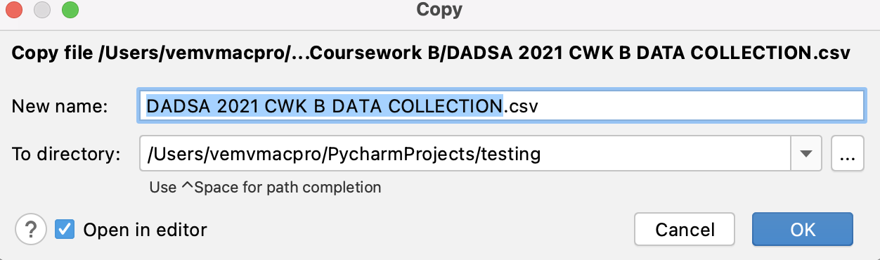

Here is DADSA 2021 CWK B DATA COLLECTION csv

just to show an example when you copy it.

4. (here is just an example but need to copy all the files to run all tasks)

5. Should have something like this: then run task 1and task 2

Short video demonstration

For the short demo video, I have two files that are the same. There will be one file that I have used that I record but is saved as a QuickTime player and another file that is saved as an MP4. There are two formats since I wasn’t sure if the QuickTime player will be compatible. Both of these videos work on my mac but wasn’t sure if the QuickTime player will work when given, so I added a mp4 version as well.

So, this is the QuickTime player file (short video demonstration of the code)

This is the mp4 version I called it ‘mp4 version short demo of code’

